**React Outputs**

**1.ReactJS-HOL**

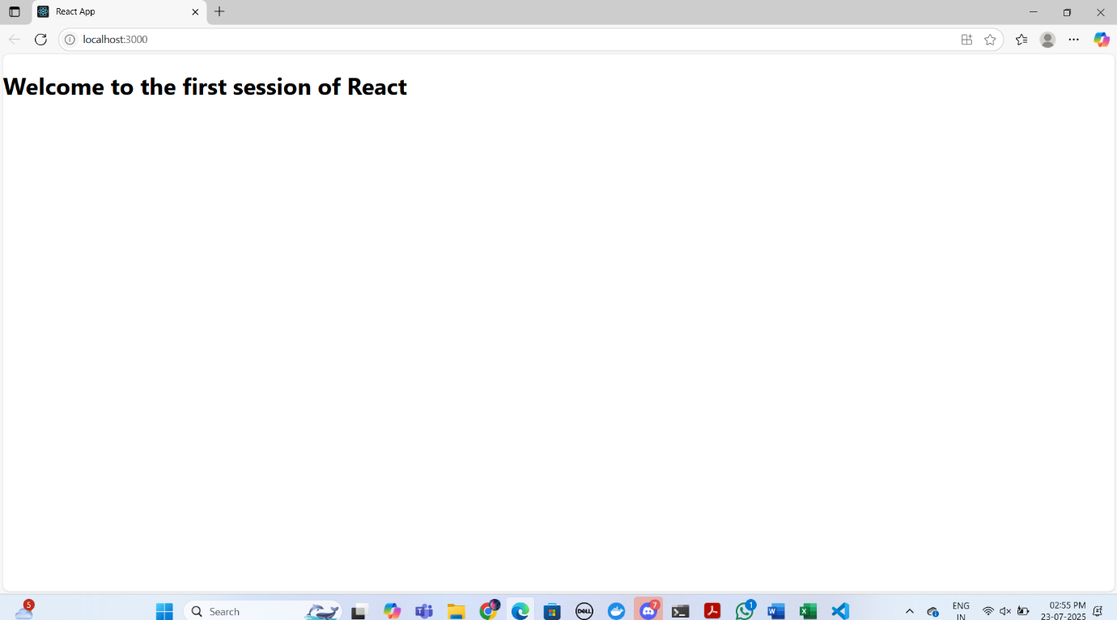

**2.ReactJS-HOL**

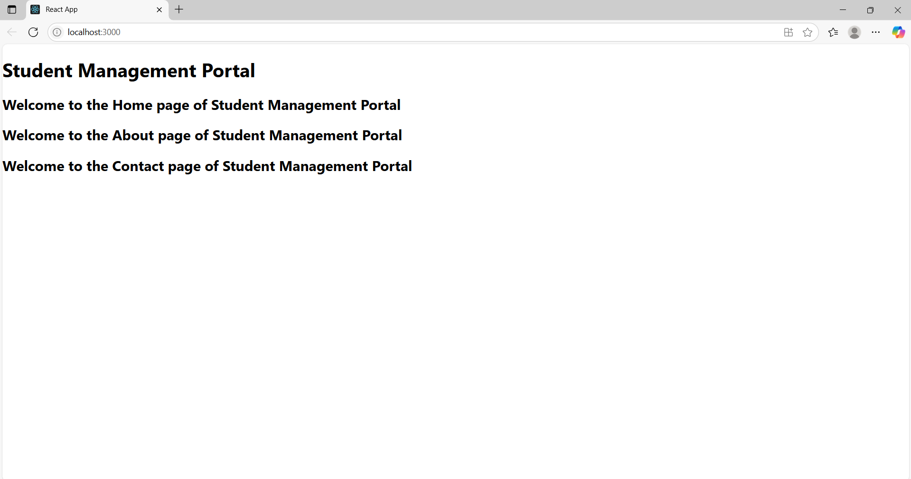

**3.ReactJS-HOL**

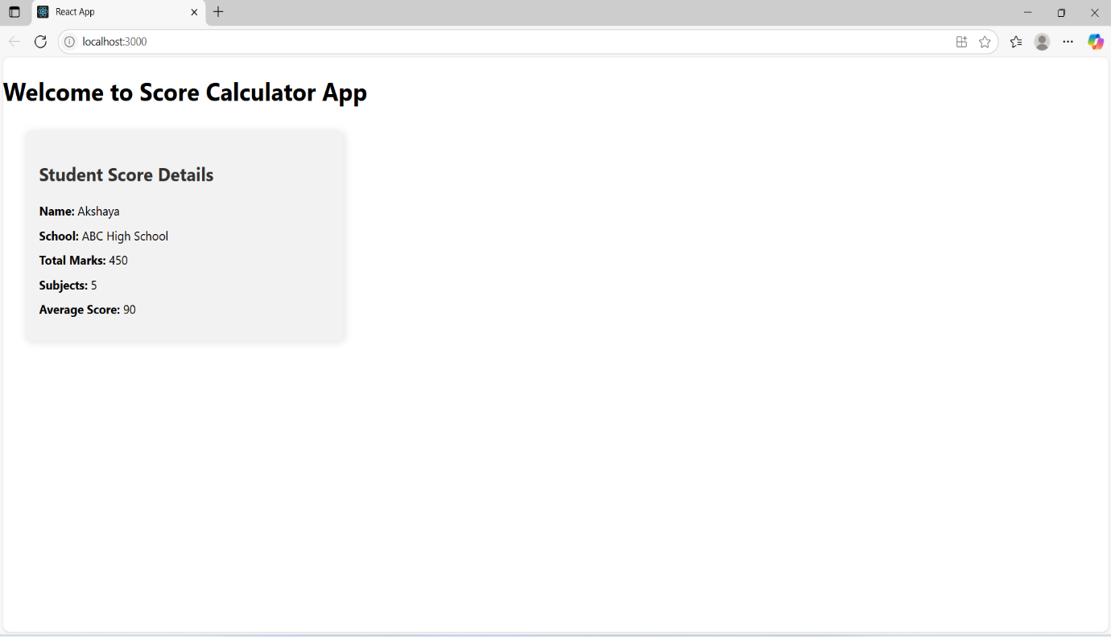

**4.ReactJS-HOL**

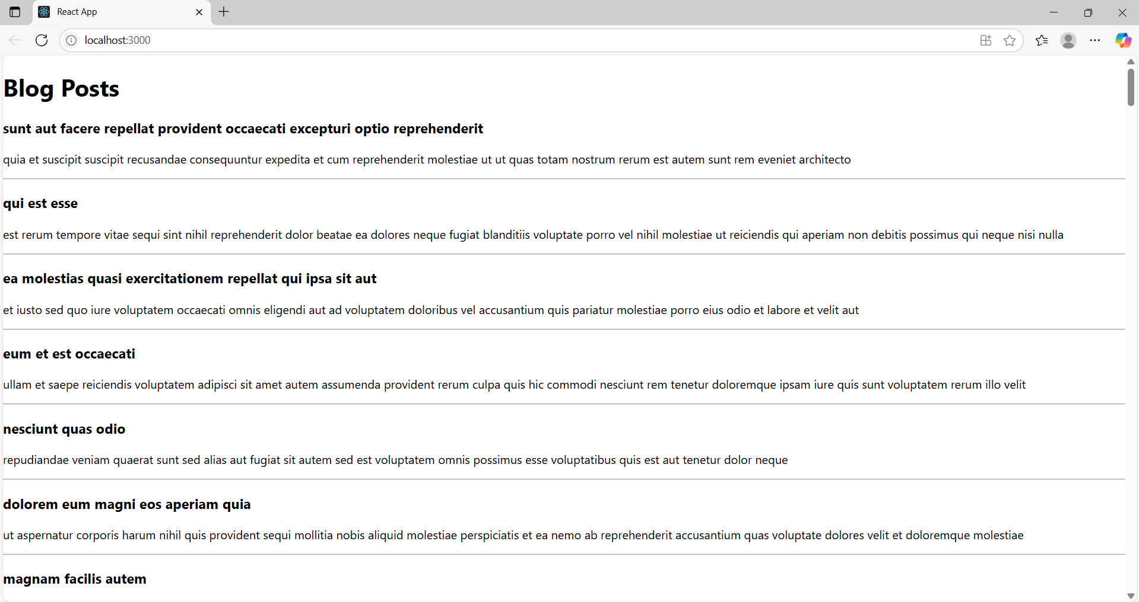

**5.ReactJS-HOL**

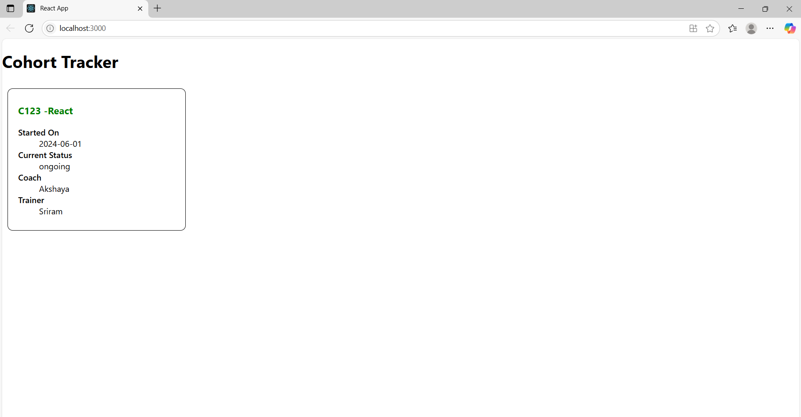

**6.ReactJS-HOL**

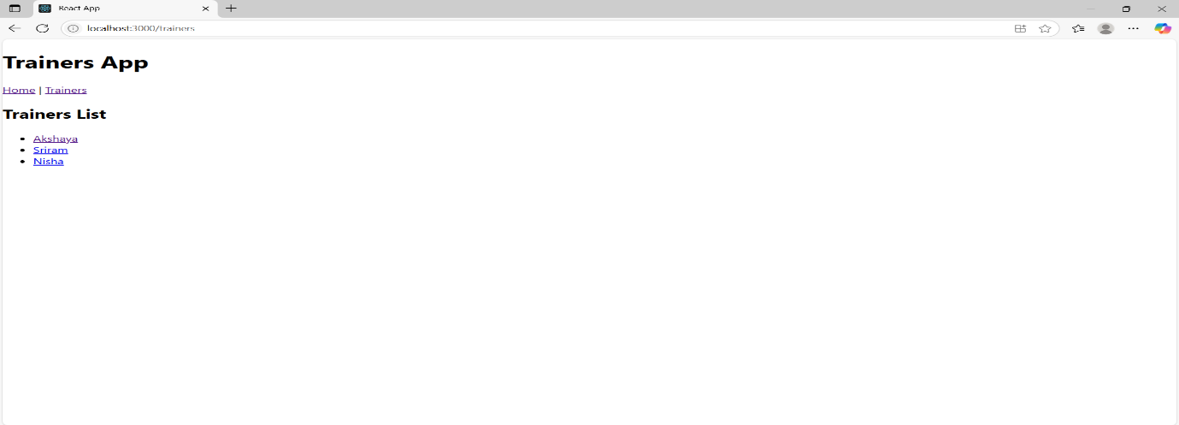

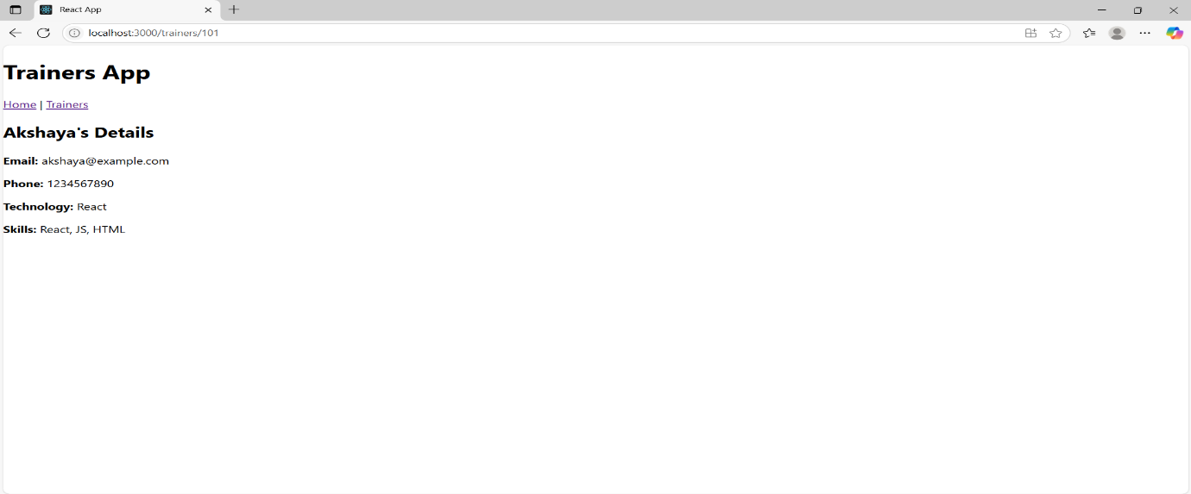

**7.ReactJS-HOL**

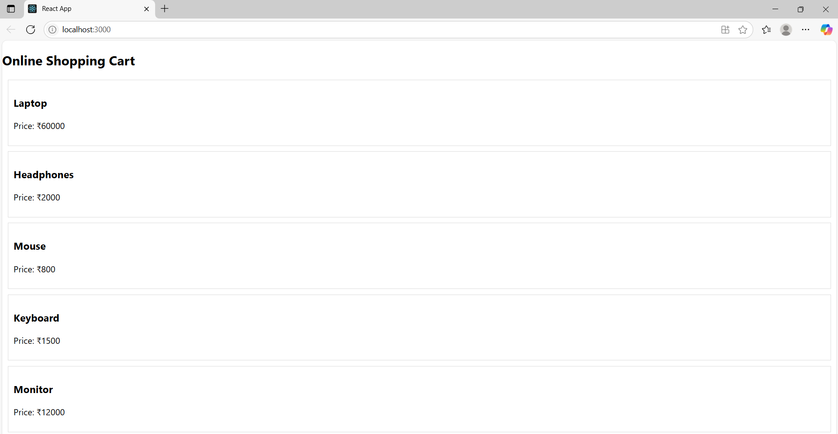

**8.ReactJS-HOL**

